**Appendix**

* + 1. Normal Q-Q plot for hypothesis 1

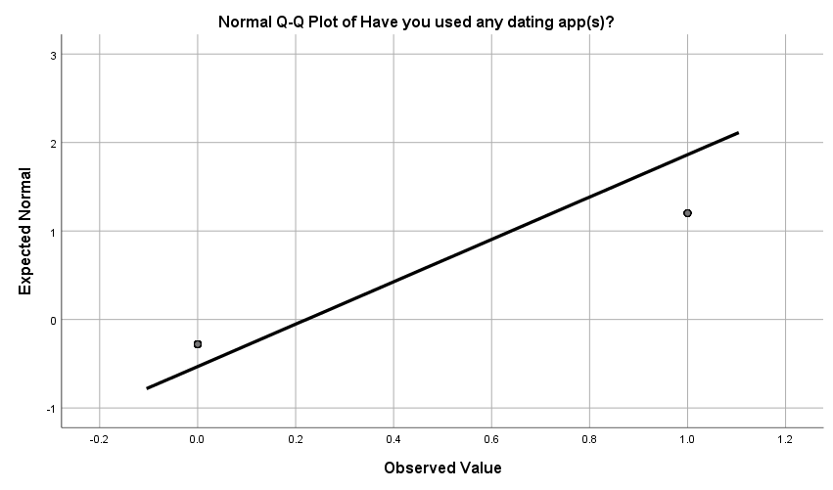

* + 1. Bar chart for hypothesis 2

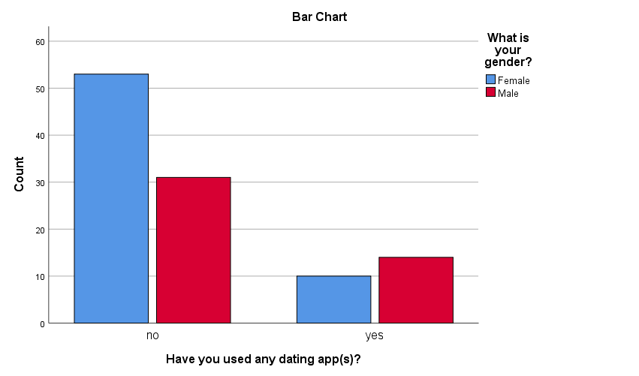

* + 1. Contingency table (with row percentages and frequencies) for hypothesis 2, chi-square test

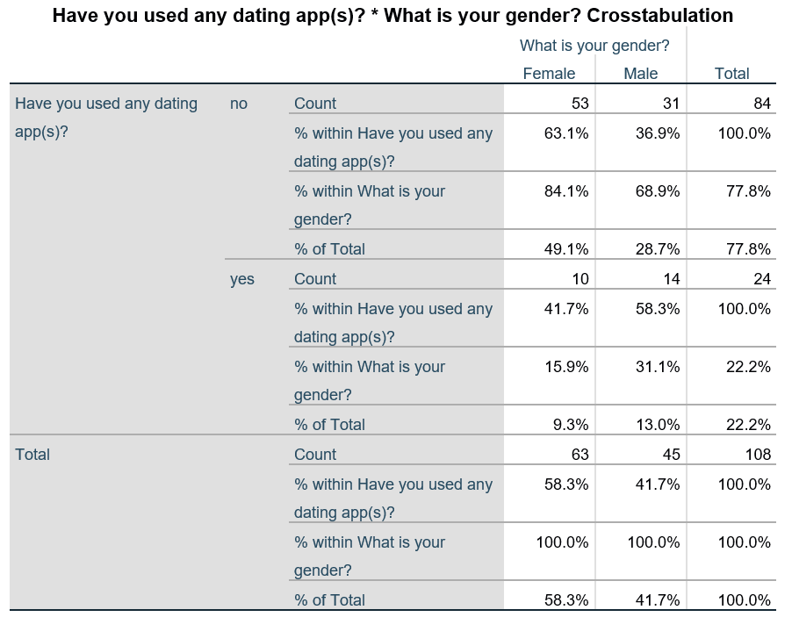

* + 1. Normality test with sexual orientation involved

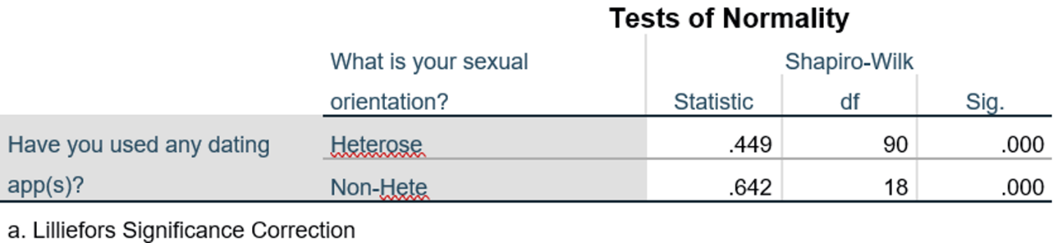

* + 1. Histogram of the frequency of heterosexual / non-heterosexual versus usage of dating apps

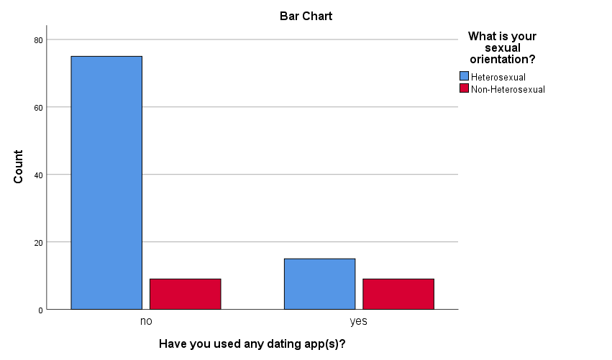

* + 1. Contingency Table for hypothesis 3, chi-square test

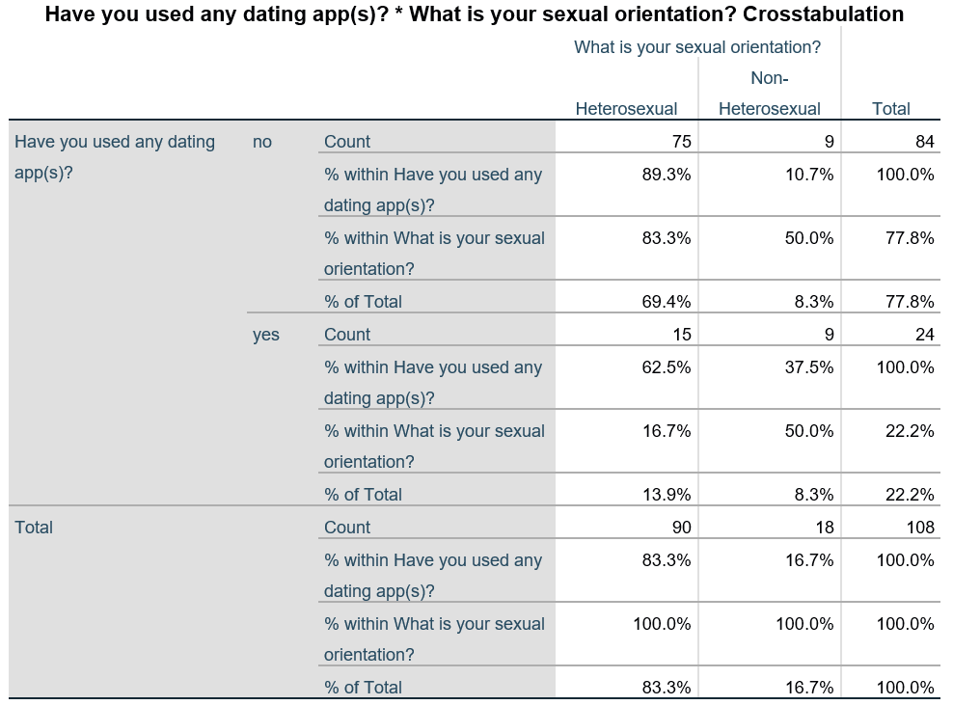

* + 1. Histogram of the frequency of male / female on their opinion on effectiveness of dating apps

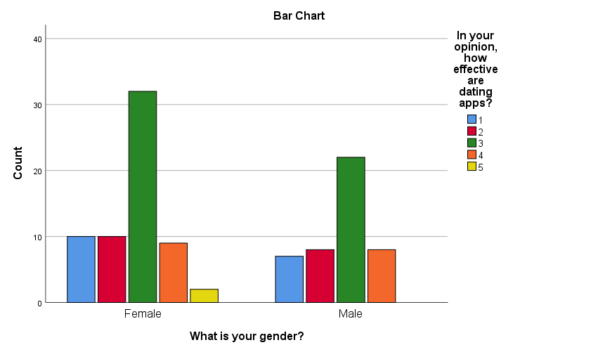

* + 1. Questionnaire “Survey on Usage and Perception of Dating Apps Among Students in University of Malaya (UM)”

1. What is your gender? (M/F)
2. Which faculty are you from?
3. What is your year of study?
4. What is your sexual orientation?
5. Have you used dating apps? Y or N

***If the answer from Q5 is Yes, jump to the Section A, else jump to Section B***

**Section A**

1. What do you use dating apps for?
2. How long have you used dating app(s)?

* Less than 1 month
* 1-3 months
* 4-6 months
* More than 6 months

1. Select the dating app(s) you have used.

* Tinder
* Bumble
* OkCupid
* JustDating
* Happn
* Mingle2
* MiChat
* Dating.com
* AsianDating
* SweetRing
* iPair
* WeDate
* Paktor
* TanTan
* MoMo
* Soul
* Badoo
* Blued
* Zoe
* FEM
* Her
* LGBT Dating
* Wapa (Lesbian Dating)
* Facebook dating
* Other (Please specify): ________

1. How comfortable is your experience in using dating apps? (Likert scale, 5)

**Section B**

1. What is your reason behind not using dating app?
2. Would you ever use dating apps in the future? (yes/no/maybe)

***End of branch***

1. Do you believe that it is possible to get a genuinely sincere partner through a dating app? (Yes/no/maybe)
2. In your opinion, how effective are dating apps? (Likert scale, 5)
3. In your opinion, how safe are dating apps? (Likert scale, 5)

(Here we are referring to getting harassed or abused online.)

1. In your opinion, how secure are dating apps? (Likert scale, 5)
   * 1. Summary of demographic data

